**BA Assignment Task 4**

1. **When we should conduct JAD in agile? JAD is a Joint Application Design?**  
     
   JAD is also knows as Joint Application Development. It is a process used to collect Business Requirements used while developing new system for a company or while working on a new project. JAD is conducted usually in the preliminary stage of a project.   
   It is used to motivate and enhance participation of cross-functional teams including all the stakeholders.

**2. How JAD is different from the daily Stand-up and Scrum Meeting?**  
  
Scrum is an agile process used for product development, it is used when we have a fixed deadline, complex requirements and tight schedule.

Daily stand-up meeting comes under scrum once we begin a sprint (series of iteration scrum). It is organized by a Scrum Master and usually is of short time about 15 mins. It is done to ensure all the team members are well synchronized with day-to-day activities and development.   
  
JAD is different from both, it is also an Agile process, but the meeting is conducted in the preliminary phase of SDLC and is lead by a Business Analyst to know the Business requirements and to know whether the application is in sync. with real time scenario and will work or not.

3**. How JAD plays an important role in terms of gathering the requirements?**  
  
 Requirement gathering is important to initiate and execute a project successfully. The most important factory of req. gathering is to accurately define project scope. JAD plays an important role here as it ensures the involvement of cross-functional teams and stakeholders to discuss and plan for the project at the early stage of SDLC. JAD are very structured and couple of techniques are used to conduct a JAD sessions such as Brainstorming, interviewing and surveying.   
JAD session will be concluded once all the requirement are met and client is satisfied with the planning of the project.

**4. Create Swot analysis of any brand of your choice.**

The Brand is selected form one of my course case study material **C & F Apparel Inc.**   
  
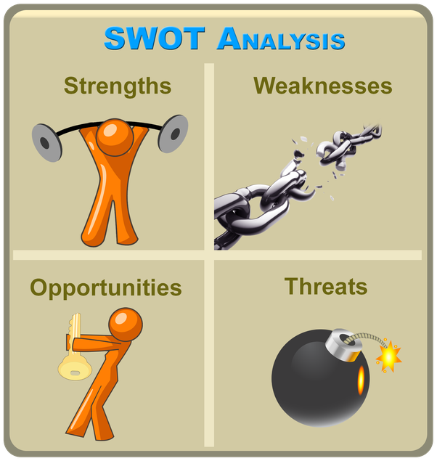

**Strength:**

* Strength: Durable and reasonably priced products
* Offers wide range of apparels products
* Changing trend with seasons

**Weakness:**

* Poor forecasting methods
* High Discounts
* High inventory obsolescence rate
* Long lead times
* Majority products outsourced
* No Retail stores owned.

**Opportunity:**

* Improve forecasting
* Develop long term contracts with retailers
* Improved Sales tracking technology for Forecasting

**Threat:**

* High loses due to bad forecasting.
* Cancellation of contracts due to failure in sales
* Calling of certain Percentage inventories as obsolete